

**Looking for an easy way to PDF your student’s work and submit to their Assignment Submission Folder?**

1. Download the CAM SCANNER to your tablet or phone:

<https://www.camscanner.com/user/download>

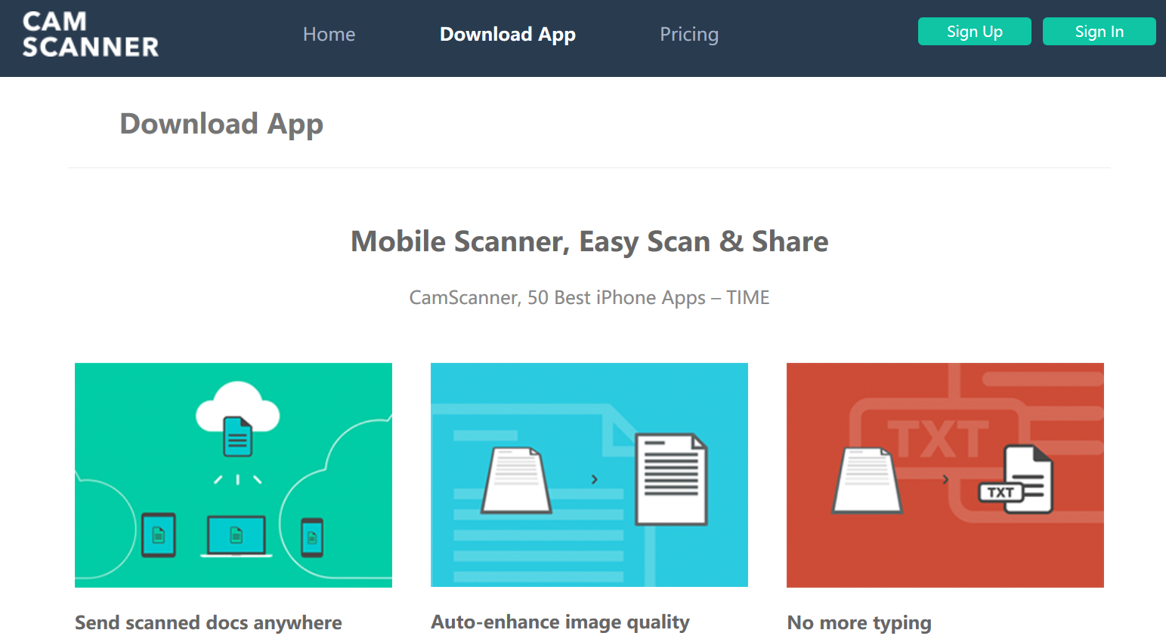

1. Use **CAM SCANNER** to take “pictures” of your student’s work and then send an email to yourself of a single document PDF. This can then be saved to your computer then submitted to Dropbox for grading.
2. See here for tips on taking images of “batch” documents for creating a SINGLE PDF.

*This will allow you to take multiple pictures of assignment pages to create a SINGLE PDF document for submission.*

[**How to take images of multiple assignments and pages to create a single PDF**](https://video.search.yahoo.com/search/video?fr=mcsaoffblock&p=cam+scanner+with+batch+documents#id=1&vid=6189316e1c9d843aa92460d127b31dba&action=click)

1. Once you have done the above batch or single photo steps above, and selected the √ symbol for each photo, you will have all of your documents in one file.
2. Press the **EMAIL** button in the lower right hand portion of the screen. (This may vary according to your device.)
3. The document list will pop up. Select the PDF option from the list and it will create an email containing your assignments as a PDF attachment. Insert your **Assignment name** in the subject line of the email and send it to **YOUR PERSONAL EMAIL**!

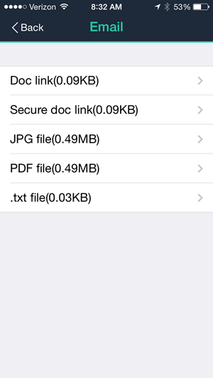 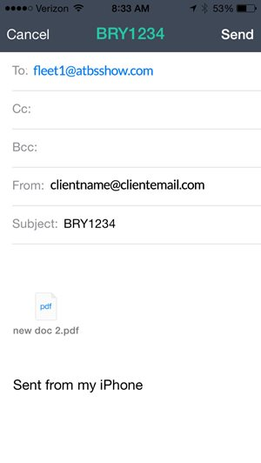

1. Once you receive it in **YOUR EMAIL** account, you will then **save it to your computer** or **Google Drive**, and submit it into the **Submission Assignment Area** as shown below for your teacher.

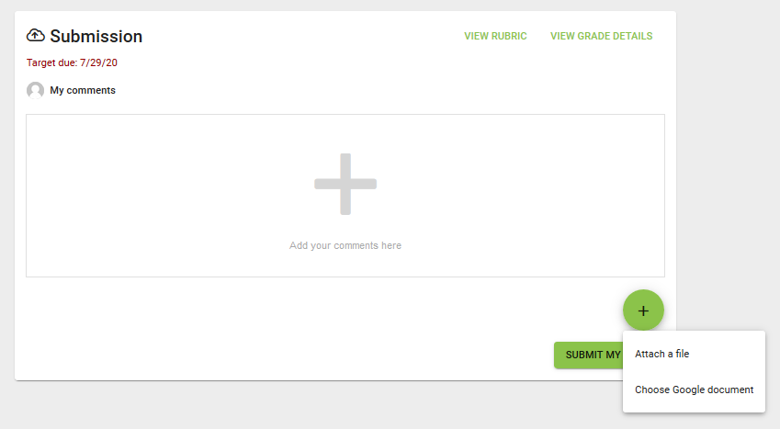

*\*CamScanner will automatically save a copy of the document in My Documents/Homepage of the application.*

**Please reach out to your teacher if you have further questions**

**on how to submit your assignments to Dropbox.**